Elephant Carpaccio exercise handout

(http://alistair.cockburn.us/Elephant+Carpaccio+exercise)

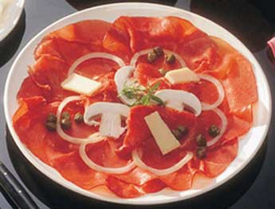

**Instructions**

1. Break into teams of 2-3 people, one workstation per team.

2. Preparation - Each team writes down *on paper* the 10-20 demo-able user stories ("slices") they will develop and possibly demo. Each should be doable in 3-8 minutes. No slice is just mockup of UI, creation of a data table or data structure. All demos show real input & output (not test harness).

3. Discussion - Instructor/facilitator leads discussion of the slices, what is and isn't acceptable, solicits ways to slice finer.

4. Development - A fixed time-box of 40 minutes, five 8-minute development sprints, clock does not stop. At the end of each sprint, each team shows its product to another team.

5. Debrief

**Product**

Accept 3 inputs from the user:

* How many items
* Price per item
* 2-letter state code

Output the total price. Give a discount based on the total price, add state tax based on the state and the discounted price.

